Jahia Book
Chapter 5 - Going Live

Jahia
9 route des Jeunes, CH-1227, Carouge Switzerland
http://www.jahia.com > The company web site http://www.jahia.net > The community web site

Version
This table records the versions of this document and their last updates
Version | Author | Date | Modifications
1.0 | Jonathan Coates | 2008-03-31 | Initial document

Summary
Page
Version 2
Summary 3
Pre-Production 5
Introduction 5
Users types 5
Effects on Jahia system load 5
Functional Validation 6
Performance 6
Jahia fine tuning 6
Improving Jahia performance 6
Java 6
Database fine tuning 7
The Jahia SQL Profiler 7
Requirements 8
Binary packages 8
Running the GUI SQL Profiler with P6Spy 8
Using the GUI 9
Request sequences 10
Jahia Caches 10
Introduction 10
Choosing output cache deployment 11
HTML cache 12
HTML cache – expiration only mode 14
Container HTML cache (Jahia 5.1 and later only) 15
ESI (Edge-Side Includes), deactivated in 5.0SP3, being rewritten for 5.1 16
ESI – expiration mode 17
OSCache 17
Rule of thumb for choosing between output cache deployments : 18
Output cache compatibility matrix 18
Configuring output cache 19
Full-page HTML cache parameters 19
Configuring ESI 20
Time-based invalidation mode 20
Testing performance 20
Configuration 21
On Jahia 21
On Tomcat 21
On the database 22
Before each test 22
Restart each computer running Jahia 22
Warm up pass 22
Tools 22
Extracting test input data 23
Template fine-tuning 23
During development 23
In production 26
Database Tuning 26
During development 26
In production 26
Other useful tools 27
Performance 29
Memory management issues 29
Best Practices 30

Pre-Production

Introduction
This document presents various deployment and fine tuning tips, in order to achieve the best possible performance when deploying high traffic and large data Jahia installations.
In order to better understand how to fine-tune Jahia for the best possible performance, we will first give a quick overview of the architecture of the application. Jahia is composed of many layers, and a proper understanding of each of them will help you build and setup the best system for deployment.

Users types
Users types define different types of load on Jahia content management installations, and we will introduce them here so that we can better explain how to deploy and configure Jahia according to the expected amount of user types.
- Anonymous users : these users are people simply navigating through the site, without any type of personalization associated with them.
- Logged-in, authentified users : recognized users of the Jahia system, which will see possibly different content than anonymous users, and will have different options for personalizing their experience on the site. This can include user profile information that is being displayed or used to personalize the page display.
- Content editors : these are a sub-class of the authentified users that are allowed to enter EDIT mode and modify content on the site. They may also control access to content if they have the permissions to do so.
- Content validators : these users are similar to content editors, except that their behavior is a little different. They mostly review content and publish it once it has been approved.
- Administrators : in charge of administrating the site, or maintaining the complete Jahia installation. They can create new sites, setup replication of content, etc.

Effects on Jahia system load
- Anonymous users are in effect the users that affect Jahia’s load the least, as they are only viewing content that is identical to all. They share the same username called “guest”, which is part of the “guest” group.
- Authentified users may introduce load because the generated HTML might be different amongst users, meaning more memory will be needed to handle them. Page generation load will be more important as they do not see them same content. This is especially true for the full-page HTML output cache system, which cases a copy of the whole page for each user. The container HTML cache and ESI sub systems are more efficient for handling this type of user. Such users do not have major influences over load on the processing server or the indexation server.
- Content editors generate and modify content. They introduce an edition load because they can enter EDIT mode (and therefore the output cache will be different for them), but they also introduce an additional load as database writes will happen when they modify or add new content. They also have an effect on the indexing sub-system when uploading files, as well as load on the processing server when doing operations such as copy & paste or import / export.
- Content validators mostly affect the processing and indexing servers as they publish the modifications to the LIVE mode.
- Administrators introduce the most varied load, depending on the operations they are performing. Site creation and deletion are also load expensive operations, as well as site replication that are similar to import/export operations.

Functional Validation
To be written

Performance

Jahia fine tuning

Improving performance of a Jahia server

Improving Jahia performance
Jahia is strongly dependant on the underlying layers to provide optimum performances. Some of these layers can be replaced or optimized in order to produce better results.

Java
JDK :Versions of the Java Virtual Machine are available from several vendors. You can check the Volano report (http://www.volano.com/report) for details and performance benchmarks of various Java virtual machine.
SUN: This is the default JVM on which Jahia is tested, and is available for almost all plateforms. The current and tested version is 1.5 and can be downloaded here: http://java.sun.com
IBM: The Java virtual machine developed by IBM produced significant improvement over Sun’s at the time of version 1.3.1, but it may not be true for more recent versions. Last version is 1.4.1, but is not available on Windows and Solaris, only Linux.
Just download the IBM JDK 1.4.1 (http://www-106.ibm.com/developerworks/java/jdk/) and install it on your system. Then change the JAVA_HOME environment variable to point the directory where the IBM JDK is installed. Jahia will now use the IBM Java virtual machine to run.
BEA: JRockit 8.1 is a certified 1.4.2 compatible JVM optimized for Intel processors, specifically middle/high-end servers (2 CPUs or more), on which performance are greatly improved over the SUN JVM.

Database fine tuning
As Jahia relies intensively on database engine for performance, you can make some optimization to improve the performance.
Install the database on a separate server.
By having Jahia and the database installed on 2 separate dedicated servers (or on a server with two CPU), you balance the load under heavy traffic. However, both servers should be located on the same local area network or linked with a fast connection in order not to impact performance.

The Jahia SQL Profiler
Generic indexes are created with a new installation of Jahia 5 but other indexes may be useful depending on the kind of content objects stored in your database and the way you structure your Jahia templates and sites.
To find out which indexes would be the most useful for your Jahia server, you can use the SQL Profiler developed for this task. It will identifies which indexes would most improve the performance of Jahia (or any other application using database, by the way) and output the sql script which will allow you to create the adequate indexes. You can download it here: http://sqlprofiler.jahia.org

Check the next paragraph for information on how to use the SQL Profiler.
The SQL Profiler is a generic tool to do statistics on SELECT queries in order to know where it is most efficient to create indexes.
This small tool, released under an Apache-based license connects to the P6Spy JDBC logger and displays in real time the queries going to the database. It uses an integrated SQL parser to build statistics on the most accessed tables and columns and can generate SQL index creation files. Other information is also gathered and displayed, such as the request time for a single request, for a class of request, and for all the requests. Sorting may be done on these views to detect database problems efficiently.
This tool can be very useful when you have a big volume of queries that you need to analyze not one by one (meaning that the specific time isn't that much of interest), but rather when you want to know what “group” of queries is taking a lot of time, such as queries on the same tables and columns but with different query values. The integrated SQL parser (built with ANTLR) is used to analyze the incoming SELECT queries.

Requirements
In order to use this tool most efficiently you must configure your JDBC application to use the P6Spy pass-thru driver. In the distribution is included a sample spy.properties configuration file that contains the default settings for connecting to the SQL Profiler socket.

Binary packages

This software is available in a pre-compiled binary form. Check out the downloads link on the following page:http://sqlprofiler.jahia.org

Running the GUI SQL Profiler with P6Spy
First you must install P6Spy onto the system you want to profile. P6Spy is a great pass-thru JDBC driver that enables you to log any requests passing through a JDBC connection so it is compatible with a lot of systems. This makes this SQL profiler compatible with as many systems.
Download P6Spy from www.p6spy.com. A link to P6Spy website can also be found on the SQL Profiler page.
Extract the file p6spy.jar from the archive file downloaded and copy it in the following directory:
TOMCAT_HOME/webapps/jahia/WEB-INF/lib
In order to help you with the configuration a sample spy.properties is provided with the SQL Profiler. Use this one instead of the one provided with P6Spy, and copy it in the following directory:

TOMCAT_HOME/webapps/jahia/WEB-INF/classes
Edit the file and look for the REALDRIVER part. This is where you configure the database driver used by Jahia. Settings are provided for various databases (PostgreSQL, MySQL, Oracle,...) but the default, uncommented driver is MySQL. This line indicates that the MySQL driver is used:
# the mysql open source driver
realdriver=org.gjt.mm.mysql.Driver
If you use another database, just comment this line and uncomment the one with the database driver you want to use. If it is not listed, you can just add a new realdriver line with the selected database driver.
For example if you use hypersonicSQL, you should found this line in the jahia.properties file:
db_driver = org.hsqldb.jdbcDriver
Copy the database driver in the spy.properties file like this:
#HypersonicSQL database driver
realdriver=org.hsqldb.jdbcDriver
and comments all other drivers.
Next replace the db_driver value in the jahia.properties file by the P6Spy driver:
db_driver = com.p6spy.engine.spy.P6SpyDriver
You’re done. Now you can launch the SQL Profiler and start Jahia. You must launch the profiler BEFORE launching Jahia. To launch the GUI simply type:
java -jar sqlprofiler.jar

Using the GUI
The GUI automatically starts in “display” mode, which means that as soon as the connection is established with the P6Spy source, the display will be updated every second, displaying the new requests that are being sent to the database.

The “Play” button is deactivated upon startup because we are already in “play”
mode. If you click on the “Pause” button, the profiler will display the statistics for all the request accumulated since either the GUI's startup or the last “reset” (more on that later). In the lower panel you will see the statistics for all the requests that are displayed in the upper pane. While in “pause” mode the display is no longer updated, but the requests are still being processed in the background. Pressing the “Play” button will enable the display updating again, and you will see the requests being updated as they come in every second. Note that when going back to “Play” mode the profile pane still displays the last “pause” results, in order to keep them visible to see the statistics longer.
The “reset” button (second from the left) purges all accumulated requests from the memory. This is practical to purge the buffer and analyze specific database

Request sequences
For a web application you could do the following:
1. Start the GUI
2. Start Jahia.
3. Press the “reset” button on the GUI
4. Make a request to Jahia
5. Press the "pause" button after the request has finished executing
By doing this we will see the statistics accumulated only during the request to Jahia. Also don't worry about being too precise for the “start” and “stop” time, as the total time is calculated based on the total time for the total of JDBC requests rather than the actual total time. In effect we get statistics about the percentage of slower requests rather than the total application processing time.
The last important button is the one on the left, which enable the user to create index files automatically based on the statistics displayed in the Profile window. In order for this to create a file, a previous “pause” must have been performed, otherwise the file generated will be empty.
If we continue the previous example, we could add the following step:
6. Press the “Save Indexes As” button, enter a file name such as indexes.sql, and save the file. If you open that file with a text editor you should see lines
such as these:
CREATE INDEX jahia_pages_def_index ON jahia_pages_def ( id_jahia_pages_def);
CREATE INDEX jahia_pages_def_index2 ON jahia_pages_def ( name_jahia_pages_def);
You can then feed the resulting file to your favorite database, reviewing and modifying it first in case some of the indexes already existed.

Jahia Caches

Introduction
Jahia uses caches to improve the performance of its input/output operations (such as reading from /writing to the database or generating the resulting HTML page). We can separate these caches into two categories:
- Backend caches : these cache layers mostly concern optimizing Jahia’s internal operations when communicating with the database, or internal work such as creating objects, accessing LDAP servers, etc.
- Frontend caches, also known as output caches or HTML caches : these caches are located in the request chain as close as possible to the HTML browser in order to serve HTML mostly from the caches instead of generating load on the Jahia backend. This leaves the backend free for other operations.
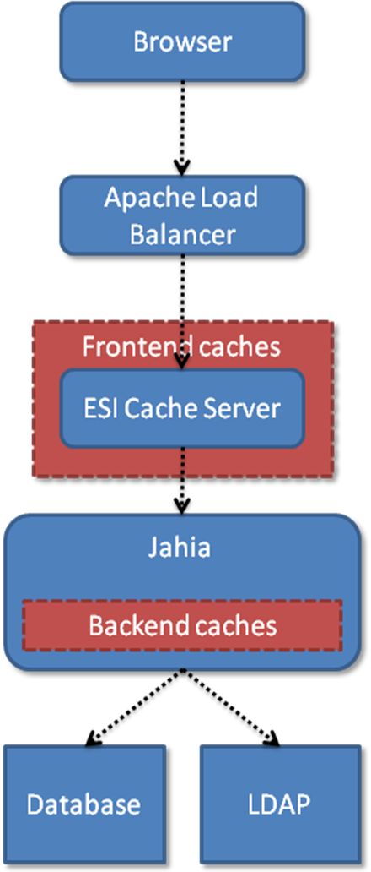
The above illustration explains where the two different caches are located in the request flow.

Choosing output cache deployment
Jahia is quite powerful in terms of performance, and offers multiple possibilities in order to cache the output of a generated page, so that subsequent requests for the page will be very fast. In best case scenarios, page response time can be below measurable milliseconds, so it is clearly an interesting topic to think about when looking at deployment possibilities.
Jahia also uses other caches, notably to optimize the performance of the back-end services when accessing the database, but these will not be presented in this section. Check out the database and Jahia fine-tuning tips later in this document for more information.
Jahia basically offers 4 different output cache solutions:
- HTML cache
- Container HTML cache (starting from Jahia 5.1)
- ESI cache
- OSCache
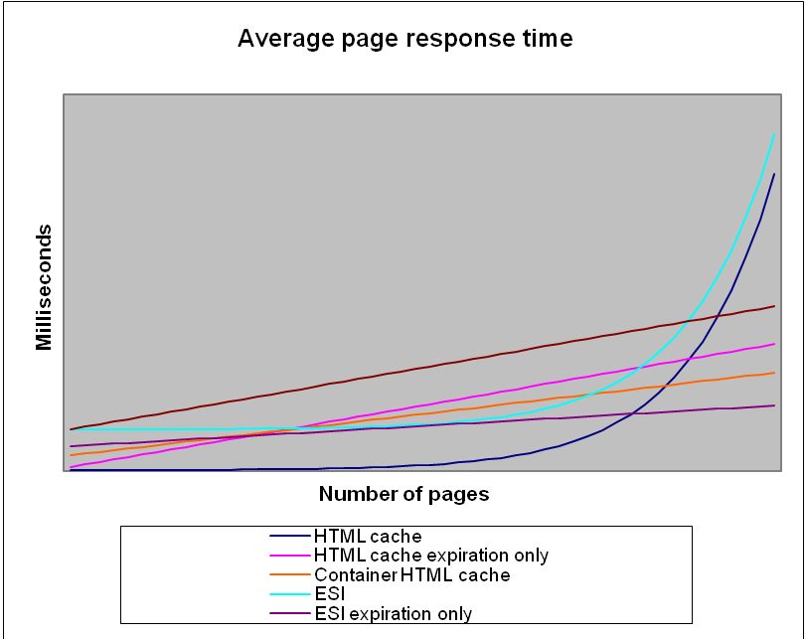
Disclaimer : this graph is for informational purposes only, and doesn’t represent real performance testing data
As we can see in the above graph, the theoretical evolution of response times versus the number of pages will help you select the best cache implementation for your deployment. For small sites, the HTML cache is the best, while for large sites, the ESI server in expiration-only configuration is clearly the most performing cache implementation.
We will now detail each cache implementation, as to give an idea what their advantages / disadvantages are.

HTML cache
The basic integrated output cache in Jahia is called the “HTML cache”, and caches the whole HTML rendered for a specific page. Since Jahia pages may be different by type of users (because of access controls at the container level), by type of navigation modes (live/edit/preview) and by language, we must actually store multiple HTML versions of the same page in the cache.
As an example, let’s say you have a site that contains 1000 pages, that has 500 authentified users (not using the same guest/anonymous profile) that are all able to edit content and that contains 5 languages, the total combination of entries that will be stored in the HTML cache could be as high as 500 x 5 x 4 (navigation modes) x 1000 = 10’000’000. If we average the size of an HTML page at 80kBytes, the total weight of the HTML cache would be 768GB (!). Of course this is assuming that each user has visited all the pages of the site which is rarely the case, and that each user has full editing rights on the whole site, which is even less likely. Nevertheless, this cache can quickly grow in size, assuming that entries are not flushed too often because of content updates.
But it is evident that as this cache is integrated into the same JVM as the rest of the Jahia server, the size of this cache can quickly become problematic. Properly adjusting the size this cache is also difficult because it largely depends on the type of expected traffic.
Moreover, as Jahia allows for content to be re-used on multiple pages, when we update this content, we will need to invalidate the HTML cache for all the target pages. In order to keep track of which content is stored on which page, Jahia uses an internal structure called “JahiaLinks” which stores information as to which content is stored on which page. In order to better illustrate this, let’s have a look at the following schema :
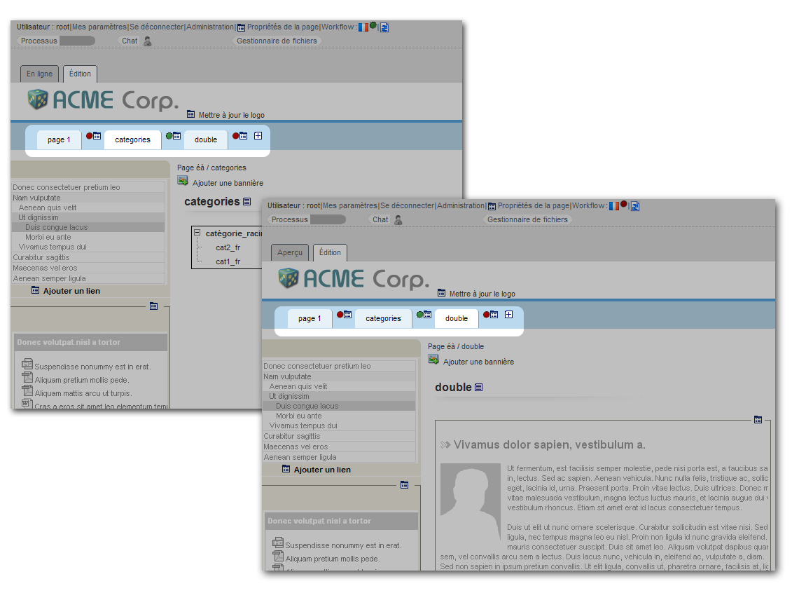
As we can see, both pages “categories” and “double” display the same navigation container list (as in Jahia even navigation are built using a container list). As the choice of displaying this container list is done in the templates, Jahia also tracks this usage in the database, in the “JahiaLinks” (aka as cross-reference table) table, because it needs to be able to access reference information without dispatching to the template. If more pages also display the same container list, the number of cross-references will grow. This structure is built on demand, so each time a page displays a new content object, the structure in the database must be updated, and therefore database write operations can occur when we are simply displaying a page, which in turn will slow down the rendering of the page.
Advantages :
- Extremely fast when in cache, can’t be faster as we are directly serving HTML from memory
- Integrated in the Jahia server, no need to setup a distinct cache proxy server
- Invalidation is handled by Jahia’s content management system, not need to take care of it at the template developer or user level, not is there any waiting time for new content to appear.
- Immediately invalidated when a change occurs
Disadvantages :
- Can consume a lot of memory which could lead, if the cache is not limited to out of memory errors.
- “JahiaLinks” cross-reference table can grow really large, and exponentially on large sites which can lead to severe performance issues on large sites.

HTML cache – expiration only mode
The expiration-only HTML cache is a configuration variation of the HTML output cache. Basically when this mode is activated, it means that the “JahiaLinks” cross-reference system will no longer be used to keep track of which pages need invalidating when a content object is modified, and invalidations will only be based on a time-based policy. This configuration is valid only for the LIVE mode navigation. EDIT, PREVIEW and COMPARE modes, as they need to always be up-to-date, will never be cached. So if you have lots of content editors, this option will put more load on the back-end system that will have to regenerate the page each time.
Advantages :
- Scales better than HTML cache on large sites
- Consumes less memory (since we don’t cache EDIT, PREVIEW and COMPARE navigation modes)
- Much faster page generation on large sites since we don’t have to maintain cross-reference data
Disadvantages :
- EDIT mode becomes slower
- LIVE content is not immediately available after a page has been published but only when the expiration time has been reached.

Container HTML cache (Jahia 5.1 and later only)
Starting from Jahia 5.1, we will introduce a new HTML cache, that, instead of caching the entire HTML page, automatically caches the output of a single Jahia container.
This cache is targeted at Jahia deployments that will be doing a lot of content re-use, which is often the case for top-level container navigation menus that usually always display the top-level pages on each page. If an editor were to change the name of a top-level page when using the full-page HTML output cache, Jahia would have to invalidate the whole cache, as all the pages display the top-level menu. This is the worst case scenario for the full-page HTML cache. Another consequence of using the full-page HTML cache is that the cross-references for this navigation content object must be maintained on all the pages, and as the site grows, so does the database table containing the references. This directly impacts the performance of the page generation as the references must be updated for each page, and as the number of pages grows, the loading of the references from the database becomes slower.
The container HTML cache is based on the assumption that we will no longer cache the full-page, but only container “blocks” of HTML. If these blocks are re-used on multiple pages, the same cached entry will be used. This is very similar to what the ESI cache server does in a more general way with fragments. Contrary to the ESI technology, the template developer cannot himself define what the fragment would be on each page.
If we take the same example as in the full-page HTML output cache example, when we update a container that’s displayed on multiple pages, with the container HTML cache we will only flush the container entry and no other cache entry will be flushed, not even the other containers in the same container list.
Another advantage of the container HTML cache implementation is that it is able to share cache entries between users, by calculating the group of users that have the same permissions on content. This is also known in Jahia terminology as “ACL groups”.
Advantages :
- Good performer on sites which re-use content on multiple pages, for example in the case of a top-level navigation menu displayed on each page
- Scales up well to large content sites
Disadvantages :
- Slightly slower than best-case full-page HTML output cache, as Jahia needs to aggregate the container fragments in order to recompose the full page.

ESI (Edge-Side Includes), deactivated in 5.0SP3, being rewritten for 5.1
ESI, also known as Edge-Side Includes (http://www.esi.org), is a caching technology that was developed to solve the problem of caching output in highly dynamic web pages. In such pages, we often only want to cache HTML fragments of the page, instead of the complete rendered HTML, as with each request the displayed fragments may change. This is also based on the assumption that fragments will be re-used, amongst different users or pages, and therefore will provide a performance benefit by generating a specific fragment only once. It also introduces the possibility of having lighter cache proxy servers serving the “edge” content without requiring all the complex back-end architecture of a full-fledged Jahia server.
From a technical point of view, ESI uses a structure similar to the “JahiaLinks” (or cross-references) to keep track of which fragments contain which container lists, in order to send the ESI caching server invalidation messages when a container is updated. The tracking of these relationships is done through an AOP system implemented using the Aspectwerkz implementation. This implementation introduces some limitations on deployment on specific application servers.
As this last aspect was causing performance and deployment problems, it is currently de-activated in Jahia 5.0SP3 and being rewritten for Jahia 5.1, using the new container HTML cache feature.
Advantages :
- Standalone caching server, doesn’t use any memory from the Jahia server
- In future versions, could be clustered
- Encourages fragment re-use between users, groups, pages
- Relatively straight-forward to integrate into templates
Disadvantages :
- Requires support for Aspectwerkz in web application server, as it relies on this library to perform it’s invalidation tracking. Another side effect is a partial slow-down on the JDK 1.4 because it doesn’t have built-in support for code instrumentation, which is a requirement of aspect oriented systems such as Aspectwerkz.
- Traffic between caching servers and Jahia servers can introduce in some cases high loads on the Jahia servers (if a lot of fragment requests happen simultaneously)
- More complicated to deploy than other Jahia output cache solutions
- Scalability issues in current implementation when the number of Jahia servers increases due to replication of the invalidation tracking information (which keeps track of which fragment contains which content objects).

ESI – expiration mode
In order to solve some of the problems in the current implementation of the tracking structure, Jahia 5.0 Service Pack 3 introduces a new mode for the ESI caching server that caches fragments only in live mode, and invalidates them using time-based rules instead of invalidation messages coming from the Jahia server. This new mode is similar to the HTML expiration-only mode that was introduced in Jahia 5.0 Service Pack 2.
Advantages :
- Same as ESI
- No need for an invalidation tracking structure that is stored on the Jahia back-end server and eats up precious memory
- No scalability problems
Disadvantages :
- Time-based expiration. Published content is not immediately visible on caching server
- EDIT mode is no longer cached, meaning that surfing in this mode will be a little slower
The future of the ESI implementation is to provide an implementation similar to the container HTML cache system, but that will be able to run in standalone mode on a dedicated caching server.

OSCache
The last solution for output HTML caching is the introduction of a legacy caching library. It is targeted at integrators that will develop and integrate into their own Jahia templates their custom logic to personalize page generation. This could also include aggregating outside content from RSS feeds, portlets, or other sources. The goal is to cache the result so that subsequent requests will be much faster. For this we recommend using the OSCache JSP tags that offer custom control of caching. Invalidation must be handled either through time-based expiration or through custom logic implemented by the integrator. An example of a custom invalidation implementation could be done using Jahia event listeners, so that invalidation could be performed even on Jahia content modifications.
For more information on integrating OSCache, please check the following URL : http://www.opensymphony.com/oscache/wiki/JSP%20Tags.html
It should also be noted that it is perfectly possible to mix OSCache integration with another output cache system, such as the full-page HTML cache or ESI, but one must be careful about the invalidation then, as it will be more complicated to handle because of the intermix between the two caching systems.
Advantages :
- Flexible solution for custom output caching
- Easy to use if a time-based expiration solution is acceptable
Disadvantages :
- Not integrated with Jahia content modifications, must be done manually by the integrator if needed
- Not a remote caching solution like ESI. The cache will consume the memory of a Jahia server which could lead to out of memory issues if the expiration policy is not properly setup.

Rule of thumb for choosing between output cache deployments :
Site type | Preferred output cache
Small “static” sites | HTML cache
Large “static” sites | HTML cache with time-based expiration mode
Small dynamic sites and personalization | Container HTML cache
Large dynamic sites with high load and personalization | ESI
Custom page rendering or portlets in pages | OSCache

Output cache compatibility matrix
The following table explains the output caches that may be activated simultaneously.
 | HTML | HTML time expiration | Container HTML (5.1) | ESI (5.1) | ESI time expiration | OSCache
HTML | x |  |  |  |  | x*
HTML time expiration |  | x |  |  |  | x*
Container HTML (5.1) |  |  | x | x*** | x | x
ESI (5.1) |  |  | x*** | x |  | x**
ESI time expiration |  |  | x |  | x | x**
OSCache | x* | x* | x | x** | x** | x
*=cache will need to be deactivated on the page that has the fragments
**=not really interesting for performance, use default ESI functionality instead
***=not optional, required

Configuring output cache
The output cache is mostly configured in the tomcat/webapps/jahia/WEB-INF/etc/config/jahia.properties file, except for the case of the ESI server where configuration must be done on it’s server (see section later in this document for ESI setup).

Full-page HTML cache parameters
# The output (HTML) cache may also be controlled in more detail with the
# following parameters.
outputCacheActivated = false
# the following value is in milliseconds, set to -1 for no time expiration
outputCacheDefaultExpirationDelay = -1
# The following setting is designed to be used for large sites (10'000
# pages and more), and will switch the output cache to a expiration-only
# mode. This means that all pages in live mode will not be invalidated
# immediately when content is published, but only after the expiration
# of the cache entry. This also deactivates the output cache in EDIT
# mode, which might have a performance impact. Also, this deactivates
# the generation of the JahiaLink HTML references building, which is
# a performance problem when sites reach large sizes. So if your
# site is getting large, it is recommended that you switch this
# variable to true and that you set a reasonable value for the
# outputCacheDefaultExpirationDelay.
outputCacheExpirationOnly = false

Configuring ESI
ESI can be configured in two ways :
- Using time-based expiration of fragments, in which case new content will only be available after a certain time for validated elements, but all the other navigation modes are non-cached. This mode is by far the one that can handle the biggest load in LIVE mode, because the server doesn’t need to do anything to track content invalidation. Unfortunately there is a slowdown in EDIT/PREVIEW and COMPARE modes as these are not cached.
- (Jahia 5.1, deactivated in 5.0SP3) Immediate invalidation upon content modification. This mode uses structures on the Jahia server so it can eat up a little more memory as well as a little more CPU, but it ensures that all modes are cached, therefore offering better overall performance.

Time-based invalidation mode
In order to launch ESI using the new time-based invalidation mode, you must run ESI without the Aspectwerkz framework so be sure to start your Jahia server using jahia.sh or jahia.bat and no longer the jahia_Esi.sh or jahia_Esi.bat (now deprecated)
In the ESI server configuration file (tomcat/webapps/ROOT/WEB-INF/data.xml) is configured to not cache EDIT/PREVIEW/COMPARE modes (as defined in the pass through rules)
The expiration of content will only happen once the elapsed time has been reached. The default value is set to 3600s (1 hour) this could be easily changed in jahia.properties or jahia.skeleton
In order to migrate an existing installation, after installing all the new versions of ESI and Jahia, in the jahia.properties the following variable must be set to this value :
esiCacheDefaultExpirationDelay = 3600

Testing performance
Along with the initial planning of deployment, it is also a very good time to plan for performance testing. In order to avoid last minute surprises, especially when going into production, it is highly recommended to have executed minimal performance testing on the Jahia servers. Actually this is not even specific to Jahia, and is in general a good idea for any web system deployment.
Testing should be developed to simulate each user type, in a manner as close as possible to the real thing, but automated so that it is possible to stress-test too. Stress testing will possibly illustrate flaws in the installations that will hopefully never occur, but give a good idea of the limitations of the system, which in turn will help planning for scaling the system even further. For example, stress testing might show that the database back-end is getting overloaded, and will help plan for looking at clustering solutions on the database side.

Configuration
In order to setup Jahia for performance testing, a few configuration parameters must be modified. Basically first you must determine your user load, which will be used as the basis for configuration of all the rest of the Jahia installation. In this example we will assume that you will be used 200 simultaneous users.

On Jahia
In the jahia.properties file, located in the tomcat/webapps/jahia/WEB-INF/etc/config directory, you must adjust the following parameters to the following values :
maxParallelProcessings = 200
The above setting makes sure that Jahia allows at least 200 simultaneous worker threads to serve the content (excluding pages served from the HTML cache). Usually in production, in order to save memory it would be best to put this as close to the “usual” load of simultaneous connections, but not much higher, so that when load starts peaking, the server correctly limits connections.
pageGenerationWaitTime = 1
The above setting controls the wait time (in milliseconds) that threads above the maxParallelProcessings value will have to wait. In our tests we set this value to 1 ms, in order to immediately reject the extra requests. Normally we should never have this case if the parallel thread limit has been properly setup, and by setting this delay very low, if an extra thread request is received, we will receive “503 - server overloaded” error messages, making us aware that we should augment the maxParallelProcessings value.

On Tomcat
In the tomcat/conf/server.xml file, modify the “maxThreads” parameter on the “connector” tag to at least 400 threads, as Tomcat is responsible to serve not only the HTML, but also all associated resources (images, CSS, Javascript). It should look like this :
<Connector port="8080" maxHttpHeaderSize="8192"
maxThreads="400" minSpareThreads="25" maxSpareThreads="75"
enableLookups="false" redirectPort="8443" acceptCount="100"
connectionTimeout="20000" disableUploadTimeout="true"
emptySessionPath="true"/>
In the tomcat/conf/Catalina/localhost/jahia.xml file, the database connection pool settings must be raised to allow at least 200 simultaneous connections. This is done by changing the “maxActive” parameter on the “Resource” tag, as shown below :
<Resource name="jdbc/jetspeed" auth="Container"
factory="org.apache.commons.dbcp.BasicDataSourceFactory"
type="javax.sql.DataSource" username="jahia" password="jahia"
driverClassName="com.mysql.jdbc.Driver" url="jdbc:mysql://localhost/jahia_502?useUnicode=true&amp;characterEncoding=UTF-8" defaultAutoCommit="true"
maxActive="200" maxIdle="30" maxWait="10000"/>

On the database
The database configuration must allow for at least the same number of connections that were allocated to the database pool configuration in the “On Tomcat” section. Please refer to your database documentation to figure out how to change the maximum number of simultaneous connections allowed.

Before each test

Restart each computer running Jahia
As long-running and stressed instances of Jahia can consume a lot of resources, especially TCP/IP connections, it is a good idea to restart the computer (not only the Jahia or web application server), before each performance test. This ensures reproduceability of test results too.

Warm up pass
Make sure that before you run your performance tests, you do once full warm up pass, as new releases of Jahia introduce a lot of precalculation that must be done only once. This way you can ensure that your performance will also be as close as possible to real-world performance.

Tools
Performance testing can be performed with many various tools, and we will present here a few of the most-used ones :
- Apache JMeter (http://jakarta.apache.org/jmeter/) : A very well known open-source tool written in Java to test performance of web applications. Apache JMeter may be used to test performance both on static and dynamic resources (files, Servlets, Perl scripts, Java Objects, Data Bases and Queries, FTP Servers and more). It can be used to simulate a heavy load on a server, network or object to test its strength or to analyze overall performance under different load types. You can use it to make a graphical analysis of performance or to test your server/script/object behavior under heavy concurrent load. JMeter requires users to build the testing scripts pretty much by hand, which can be a little tedious at first, but the interface for building the scripts requires almost no programming.
- OpenSTA (http://www.opensta.org/) : OpenSTA is a distributed software testing architecture designed around CORBA. The current toolset has the capability of performing scripted HTTP and HTTPS heavy load tests with performance measurements from Win32 platforms. However, the architectural design means it could be capable of much more. OpenSTA uses a proxy server to record requests and then generates scripts that can be edited to make them more configurable. The scripting language can be quite cryptic at times and the generated scripts are harder to maintain than JMeter handcoded scripts.
- Mercury LoadRunner (http://www.mercury.com/us/products/performance-center/loadrunner/) : the leading commercial performance testing tool.
You can find more tools that will help you test performance in our “Tools” section at the end of this document. Mostly what we have not included in this section are profiling tools that can be used on the server to diagnose the cause of performance bottlenecks.

Extracting test input data
In order to build the datasets for testing, usually you will need a list of valid page IDs that you can use to test browsing the site for example. You can retrieve the list of accessible page ID with the following SQL request :
SELECT id_jahia_pages_data FROM jahia_pages_data WHERE pagetype_jahia_pages_data=0 AND workflow_state=1 ORDER BY id_jahia_pages_data;
The above request returns the LIVE mode pages, i.e. pages that have already been validated. If the objective is to load test in EDIT mode, the request must be slightly modified to include the non-validated pages :
SELECT DISTINCT id_jahia_pages_data FROM jahia_pages_data WHERE pagetype_jahia_pages_data=0 AND workflow_state>=1 ORDER BY id_jahia_pages_data;

Template fine-tuning

During development
- Use the Jahia API with care
If you plan to develop advanced Jahia features in addition to basic templates (for example if you plan to automatically create a default set of pages for each new virtual site or if you plan to automatically import external content into the Jahia content repository), please take care to fully understand the Jahia model and to fully and extensively test your custom developments before putting them in production and in the hand of the end-users. Certain Jahia operations are quite complex and tricky (e.g. the page creation operation). Having full access to the source code and to all the underlying Jahia classes, doesn’t imply that you can use them as-is without fully understanding the Jahia object model. You risk corrupting the integrity of the database by forgetting to integrate certain mandatory checks or certain tests in your code.
Moreover the Jahia developers does not guarantee that the Jahia API will not change from a point release to another. So your workarounds or your advanced features may not work anymore in the next releases. Consequently, think twice before implementing such advanced features. Always think if it isn’t better to contribute your changes to the community or to sponsor a longer term development rather than implementing a short term custom workaround which risks becoming rapidly unmaintainable and may corrupt your whole content model if badly implemented.
Also, if you are trying to import content, please always refer to the built-in features, such as the XML import mechanism that can cover a lot of needs.
- Use OSCache or ESI to cache fragments
OSCache can perfectly be used for fragments of the page, which take much time to render and where the result is always the same, especially if it is the same on every page (header, footer, menu, last 5 news,...). However you might want to use it only in LIVE mode, as in EDIT mode you might want to always see the latest items, even if the page render time is a little slower.
You could do it like this:
<%
ContainerBean boxCont = (ContainerBean) pageContext.getAttribute("boxContainerBean");
int boxContainerId = boxCont.getId();
boolean isCacheActive = jData.gui().isNormalMode();
%>
<cache:cache time='<%= isCacheActive ? 120 : 0 %>'
key='<%="box" + (new Integer(boxContainerId)).toString()%>'>

[... the display of the box...]

</cache:cache>
In this example the box will be cached in LIVE mode for 120 seconds. You can decide whether you want to cache a fragment for minutes or hours. It depends how often it changes. For instance the header and footer will not change often. For the navigation, it might happen more frequent that new pages are coming or old pages are being deleted. In order to prevent 404 errors, if a fragment is still showing a page, which has been deleted, you could also call
<cache:flush key='<%="box" + (new Integer(boxContainerId)).toString()%>' />
in EDIT mode on the JSP, where the container gets changed. If you are using a cluster, then you should also consider the configuration, described here: http://www.opensymphony.com/oscache/wiki/Clustering.html.
For the key, it also depends whether you are using access rights on the container list, so each user might have a different view. For this case you might want to add the user-id to the key, then the fragment will be cached per user. You should surely limit the time on these fragments.
To use the OSCache you need to deploy the JAR to the lib directory of the Jahia webapp, you need to add the oscache.tld to the web.xml and then you can use the taglib in your templates.
As mentioned in the title of this tip, it is also possible to ESI to cache fragments, and this behaves much in a similar way than the OSCache solution. For more information on how to use ESI to cache page fragments, please refer to the ESI integration documentation.
- Avoid doing unnecessary container and field definitions
You can re-use field definitions between multiple container definitions (if using the Jahia API calls). Also, container defs and fields defs are shared for all pages using the same template, no need to instantiate them more than that.
- Avoid calculating default values for field definition dynamically
Avoid calculating default values for field definition dynamically if possible. If a default value is calculated for example using the current user name, the definition will be modified each time a new user comes on the template. Updating container definitions is an expensive operation and might lead to coherency problems if a template is loading content from a definition while it is being updated
- Avoid making definitions on pages that will only retrieve the container list content
This is especially true for absolute container list usages. We do not need the definition to be executed just to retrieve the content of the container list.
- Avoid building interfaces with lots of hierarchies
Avoid building interfaces with lots of hierarchies, as retrieving sub-pages and content can become expensive operations as the sites grow larger. An example of this is the classic DHTML scroll-down menu, which, if displayed on every page of the website, can become a real performance problem because Jahia will have to track it’s usage on all pages, to know which pages to flush when content is added / modified (when the built-in full page HTML cache is used).
- Think about total page loading time
When designing Jahia templates, remember that the total page loading time not only includes the HTML generation, but also all the surrounding resources that will be loaded from the HTML links such as: Javascript source files, CSS files and images. You can use a tool like Firebug (http://www.getfirebug.com/) for Firefox to analyze total page loading time. A slow loading resource can also give the impression that the whole system is slow because some browsers “wait” on a resource before displaying the page. Also check the configuration of your application server so that it has enough free connections to serve all the requests including the resources. Also, remember that access to external resources such as external images, RSS feeds, external Javascript files or other resources can cause problems if the connection with the external site is slow, or if the Internet connection is not always available.

In production
- Precompile your set of templates
If you do not plan to change your set of templates often, you may precompile your templates with the jspc command or another similar tool. By default, the Jahia engines (i.e. the edition pop-ups) are already pre-compiled.
In Jahia 5 we have also introduced a new servlet, which you can trigger after deployment of new templates or template changes. Simply call http://<yourservername:port>/jahia/precompileServlet and then select an option by clicking on the link.

Database Tuning

During development
- NEVER use your development database in production
While developing or customizing your new set of templates or portlets, you will most likely generate some Java exceptions. This will cause application server crashes or require Java processes to be terminated quite abruptly. All these actions may corrupt unfinished Jahia transactions and indirectly also corrupt your underlying database. Therefore never use a development database in production. Always migrate your set of templates, once fully tested, on a fresh or on a stable production server. If you want to test your templates with some real content, always copy the database and files from the production server to your development workstation. Never do the opposite.

In production
- Do not use HSQLDB in production.
Jahia is by default prepackaged with Hypersonic SQL. This is a small Java database embedded in Jahia for demo or development purposes only. We do not suggest using this database in production. If you want to use a free and open source database, please consider using MySQL or PostgreSQL.
- Database profiling tools
Use database profiling tools to figure out if some tables are being accessed in sub-optimal way, adding indexes if necessary (for example SQL Profiler, for more information see the “Tools” section)
- MySQL Query cache
Make sure database is properly configured for performance : activate query cache on MySQL. More information about the MySQL query cache can be found here : http://dev.mysql.com/doc/refman/5.0/en/query-cache.html
- Vacuum the database
On PostgreSQL : schedule VACUUM FULL operations daily, and configure auto-vacuum so that it doesn’t interfere with high-load times. You can find more information here : http://www.postgresql.org/docs/8.2/interactive/sql-vacuum.html as well as here : http://www.postgresql.org/docs/8.2/interactive/maintenance.html
Equivalent index reconstruction and table cleanup operations may exist on other databases, and are strongly recommended if they improve performance. Here an experience database administration (DBA) is highly recommended to make sure the database is always optimally configured.
- Update Jahia database indexes
In order to update the indexes when deploying a new Jahia build, you must first delete all the standard indexes from the database, and then execute the script jahia-schema-index.sql that can be found in the directory : tomcat\webapps\jahia\WEB-INF\var\db\sql\schema\DATABASE_TYPE where DATABASE_TYPE is the type of database you are using.

Other useful tools
In this section we present tools that help integrators diagnostic possible errors and performance bottlenecks.
- YourKit Profiler (http://www.yourkit.com/) : a powerful JEE and Java profiler, with low overhead. YourKit introduces about 20-30% slowdown, but it is still acceptable to run in production environment. It allows to diagnose both CPU and memory usage, as well as analyze JEE traffic to the database, servlets, etc. It is a very good tool to get an idea of where the problem might come from. An alternative to YourKit is JProfiler (http://www.ej-technologies.com/products/jprofiler/overview.html), is generally more precise, but has more overhead and therefore is not suited for production analysis.
- JAMon, already integrated with Jahia, is a great tool to monitor performance on production servers. You can find more information about JAMon here : http://jamonapi.sourceforge.net/. This tool enables you to see in real time the performance of the internal Jahia services and figure out which back-end system is causing any bottlenecks. This might be a good way to for example illustrate a performance problem of a remote LDAP server, or the database server that might not be answering requests fast enough. It should be noted that JAMon can be activated “on-the-fly” while the Jahia server is running, without requiring a restart, and that it has about a 10-20% impact on performance while monitoring is active. So it is an ideal way to start examining internal performance on production system without the need to install any complex tool.
- SAP Memory Analyzer (https://www.sdn.sap.com/irj/sdn/wiki?path=/display/Java/Java+Memory+Analysis&) is a great tool to analyze JVM memory dumps, especially to diagnose OutOfMemory exceptions. This tool will give a detailed inside view of all the objects in memory, as well as their parents. Information on generating heap dumps can be found here : https://www.sdn.sap.com/irj/sdn/wiki?path=/pages/viewpage.action&pageId=33456
- MySQL Advisors (http://www.mysql.com/products/enterprise/advisors.html) : If you are deploying using MySQL, the advisors are a part of MySQL Enterprise version that allows to fine-tune your MySQL installation to your custom usage of the database.
- Java 6 Monitoring tools (http://java.sun.com/javase/6/docs/technotes/guides/management/index.html) : Java 6 introduces new monitoring tools such as JConsole, which are extremely useful to monitor basic system performance until real load scenarios.
- BEA JRockit JVM (http://www.bea.com/framework.jsp?CNT=index.htm&FP=/content/products/weblogic/jrockit/) : a solid alternative to Sun’s JVM is BEA’s JVM, which provides good performance and solid monitoring tools.
- Jahia Doctor (http://cvspub.jahia.org/cgi-bin/cvsweb.cgi/jahiadoctor/): The Jahia team developed a convenient utility to carry out integrity tests on your Jahia database. This utility attempts to automatically fix certain problems.
Warning: This tool is a low-level development tool. Please use only against a fully backed-up copy of your database and, if automatic-fixes are enabled, please make in-depth tests on the resulting database before migrating it back into production.
- SQL Profiler (http://sqlprofiler.jahia.org/) : the Jahia team has also developed a small utility to automatically regroup and identify the most frequently used SQL queries and, if necessary, to automatically generate new database indexes. This tool may be useful if you have developed new SQL-intensive Jahia features. It should be noted that YourKit is now also able to profile SQL requests and may be more easy to use than this tool.
Finally if you still cannot determine the source of your problem, please contact a Jahia expert. You could first submit your problem to the free Jahia mailing lists. Please do not forget to give as much information as possible (OS used, Jahia build used, database used; stack trace of the exception (if any), etc…) so that the community can help you identify and solve the issue. If this is not possible by email, you can buy some commercial support tickets (www.jahia.com/support). Jahia experts will then spend some time re-installing your full Jahia environment and carry out extensive performance tests and diagnostics.

Performance

Memory management issues

Best Practices
To be written

